**Dominating controls**

Start of Season

- remains pretty stable from 1982-2011

example: 2005

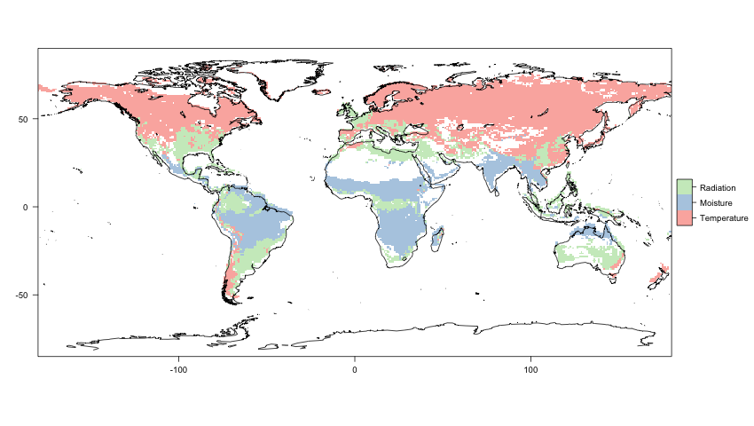

EOS

* lots of variability

2003

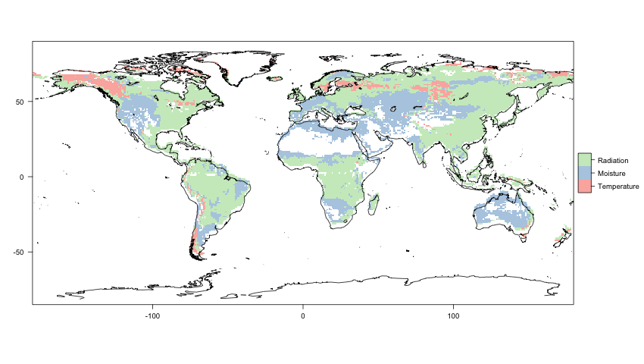

2002

